ECT286 Final Project Report
Conveyor Belt Using PLC
This project utilizes Ladder Logic and a PLC to control an auto filling conveyor.

Shawne Gambrill
(Automation and Control Systems)

ECT286

Professor: William Golden

DeVry University
College of Engineering and Information Sciences

2023

Executive Summary
This class was heavily focused on using PLCs to control processes. According to ProcessSolutions.com, PLCs were initially developed to replace large banks of relays. Dick Morley, the father of PLCs developed the first PLC and started Modicon in 1968. (Brown, n.d.) PLCs went through several iterations over the years and Allen Bradley became a major contributor to those changes. Allen Bradley’s newest platform, ControlLogix, is universally used and was first introduced to the market in 1997. (History of Allen Bradley PLC, 2017)

This report details the Final Project for ECT286 which utilized a PLC to control industrial systems. The report starts with a basic introduction describing what the finished project does. Next, is a more detailed technical overview of the project, followed by the outcomes of the project. The next sections include materials needed for the project, the ladder logic used, and proof that the project performed as it should. The report closes with lessons learned and references.

Table of Contents
Introduction 1
Project Description 1
Project Objectives 2
List of Material 2
Project Design 3
Test Results 4
Lessons Learned 6
Author's Biography 6
Works Cited 7

Introduction
The project involves automating two conveyors. The first conveyor fills a box with five items. The second conveyor moves the filled box and replaces it with an empty box.

Project Description
The project controls the two conveyors using a PLC programmed with Ladder Logic. The Logic consists of 8 rungs. The first rung, 000 is the Start/Stop Latching Rung. This rung allows the equipment to be started or stopped using a Normally Opened Push Button. The start button is Input I:1/14 and the Stop Is I:1/15. If the rung is true, the output B3:0/0 which is the latching bit will be energized. This not only latches around the start, but also enables every other rung in the program to run. The second rung, 001 Enables the filling conveyor to run. The latching bit must be energized, and a box must be detected initially on Input I:1/1. The Done bit on Timer T4 must also be energized. If these are all true, then the Output O:2/0 is energized which starts Conveyor Belt 1. That output also latches around the box detection. The third rung, 002 counts the items placed in the box. It contains the latching bit, as well as the part detection sensor on Input I:1/0. This would typically be a proximity sensor, light curtain, or limit switch, but for simulation in this project I used a Normally Open Push Button. Each time the Part Detection Bit is energized, the Count Up Timer (CTU) increases. The accumulator on the counter starts at one and the preset is set at six causing the timer to count to 5 before energizing the C5:0/DN bit. The fourth rung, 003, has a timer which allows the filling conveyor to run for an additional 20 seconds after the fifth item is added to the box. It also contains the latching bit, but also contains the Latching motor 1 bit B3:0/1 from rung 004. If both bits are energized, a Timer On Delay (TON) starts and runs for 20 seconds before energizing the Done bit. The fifth rung, 004, creates the Latching motor 1 bit which is utilized in rung 003. It also uses the latching bit, but also needs the counter’s done bit C5:0/DN to be energized and the Timer T4:0/DN bit to be off to energize the Latching motor 1 bit B3:0/1. This bit also latches around C:5/0DN bit so that the latching motor bit will stay energized after the counter reaches five and until the T4 timer is done. The sixth rung, 005, Operates the Box Conveyor. It also uses the latching bit as well as the C5:0/DN from the counter but also utilizes the Box Detection Input I:1/1. Like the item detection, this would typically be a sensor but for this simulation I used a Normally Open Push Button. If the Latching bit and Counter bit are energized and there is not a box detected, the Output O:2/1 is energized to run Conveyor Belt 2, this also latches around the C5:0/DN bit so that the conveyor will run until a box is detected. The seventh rung, 006, is the reset for the Count Up Timer (CTU), once the accumulator matches the preset, the done bit is energized on this rung initiating a reset of the CTU back to 1. Finally, the last rung, 007, is the End rung which enables the program to start scanning back at the top of the program.

Project Objectives
The objective of the project is for the equipment to run automatically while placing 5 items in each box and then replacing the now filled box with an empty box.

List of Material
For the Project Simulation, all that was needed was the LogixPro simulation software. For a real-life project, a small PLC with a processor, 1 digital input card, and 1 digital output card would be needed. For a new ControlLogix processor, Studio 5000 software would be required for programming. Field devices would include the Start and Stop Push Buttons, as well as the sensors used for item detection and box detection. Finally, appropriately sized motors and conveyors would be required for both the fill line and box line.

Project Design
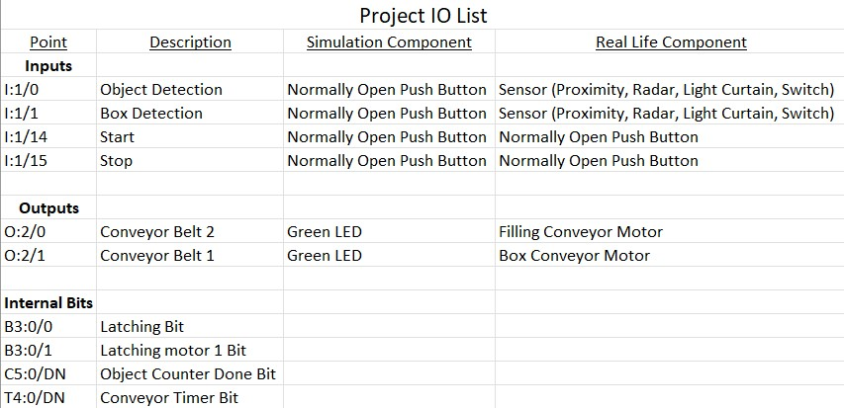
I broke up the screenshots of the Ladder Logic used in this project for visibility reasons. The first shot has Rungs 000-003.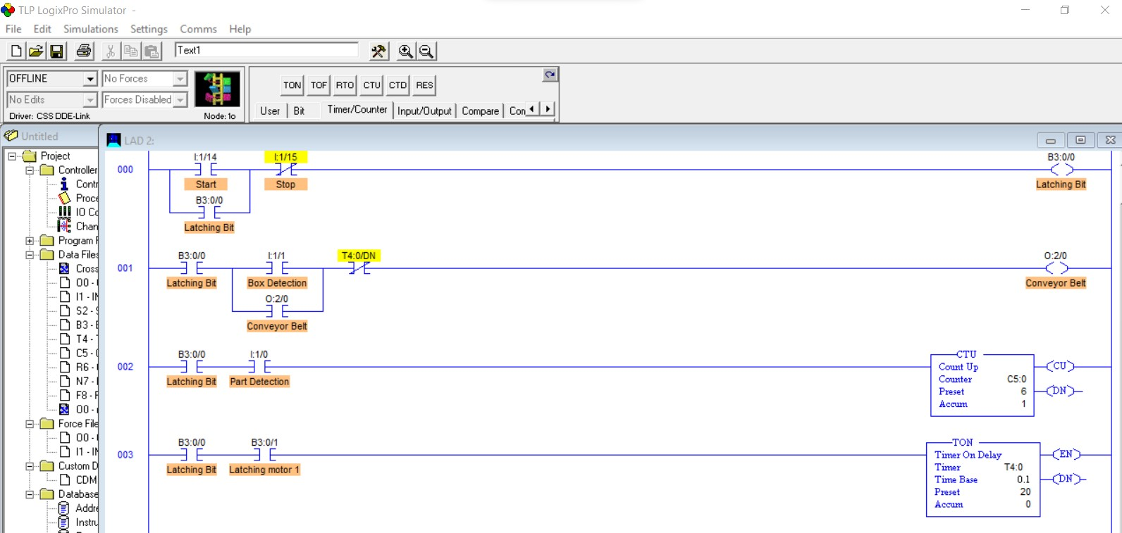
The second shot contains Rungs 004-007.
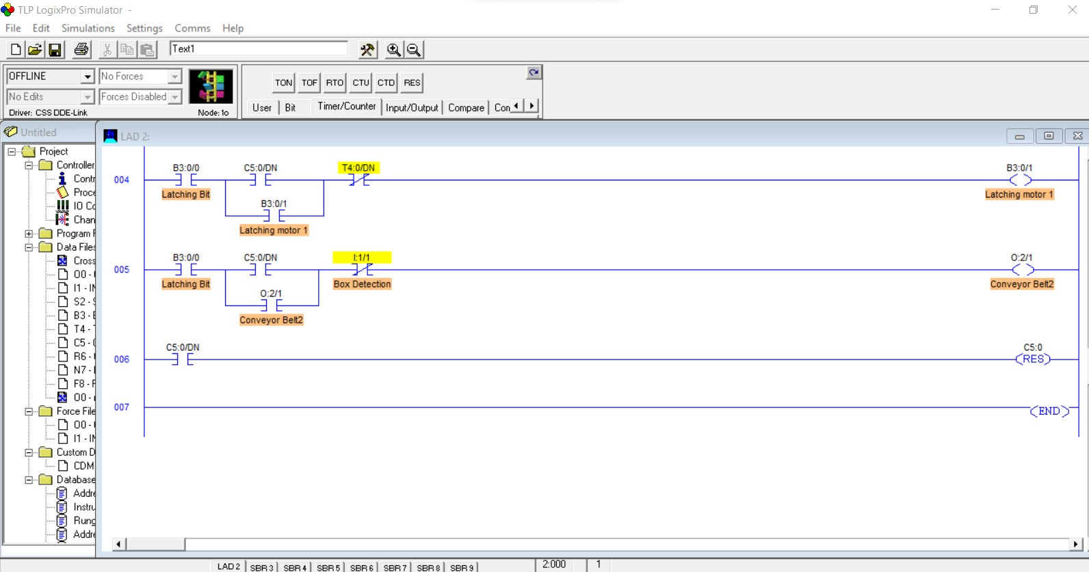

Test Results
I have broken down the simulation into four screenshots showing the program working during each step of the process. The first shot is of the system started and the filling conveyor running. Notice the Green LED on O:2/0. 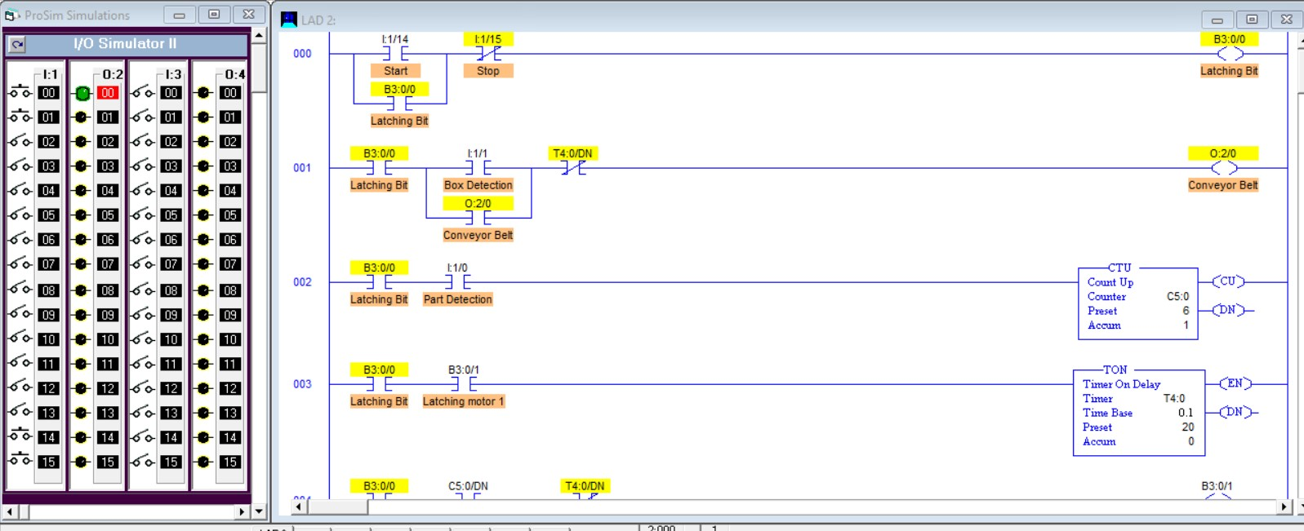
The next shot shows the filling conveyor still running as well as the CTU counting detected items. 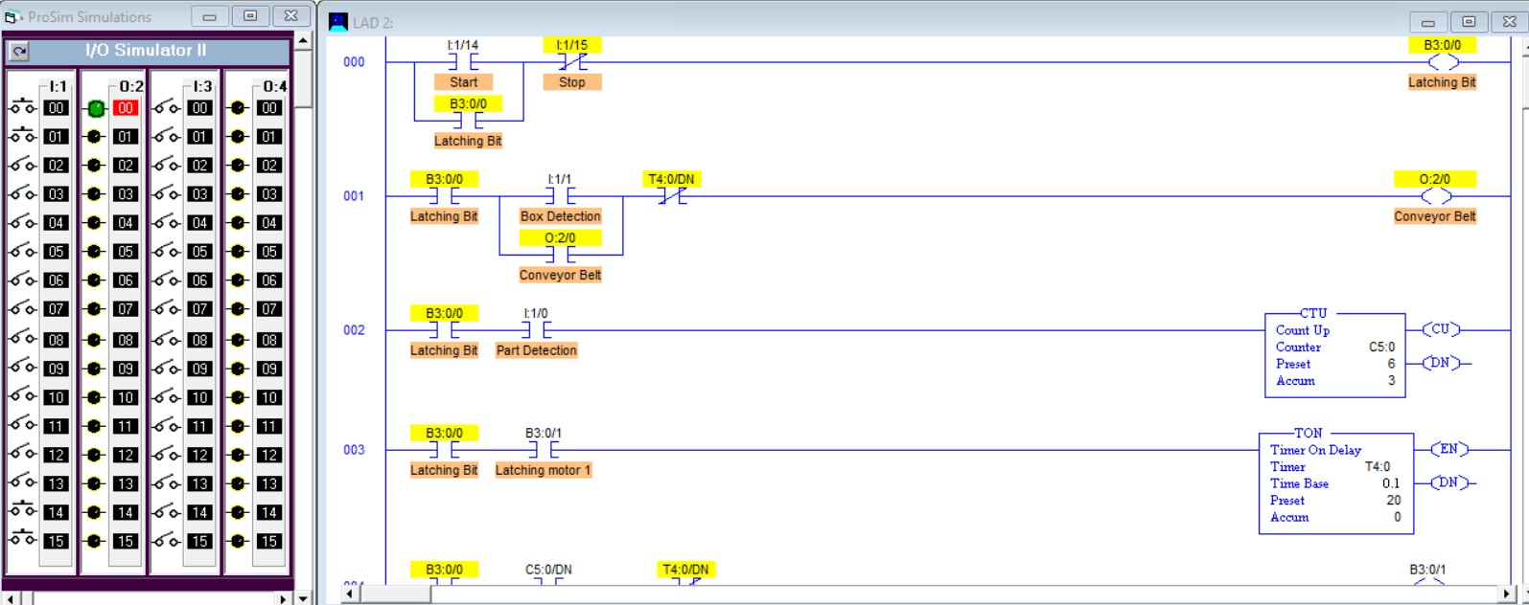
The next shot shows the box conveyor running. Notice the Green LED on O:2/1. Also, the filling conveyor is off and the CTU has reset back to 1. 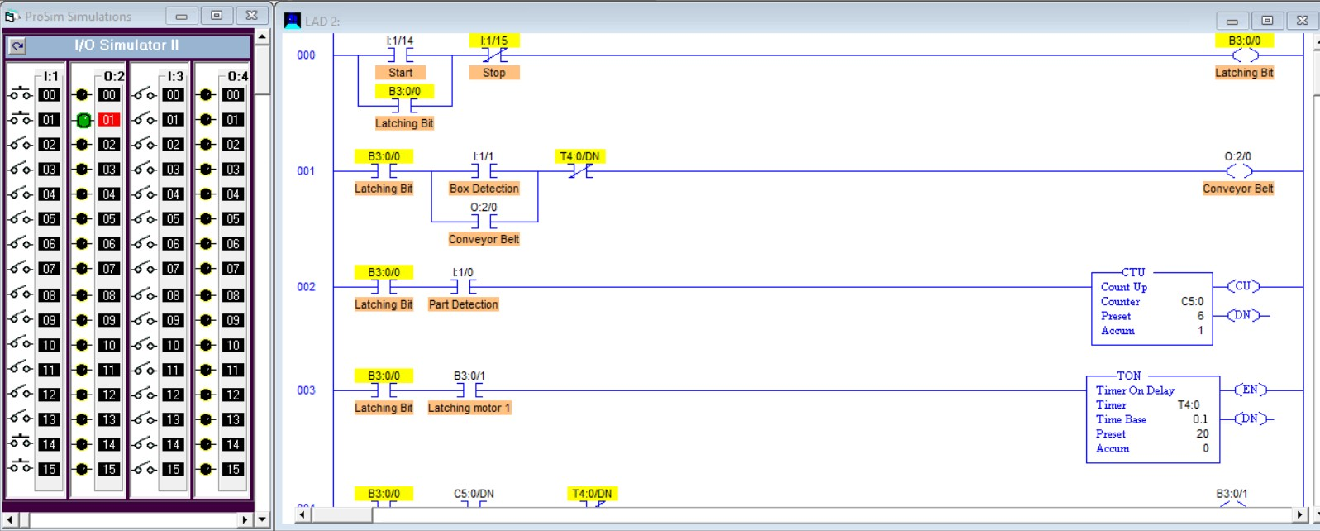
The final shot shows that the box has been detected, the box conveyor has stopped, and the filling conveyor is running again, Green LED on O:2/0. 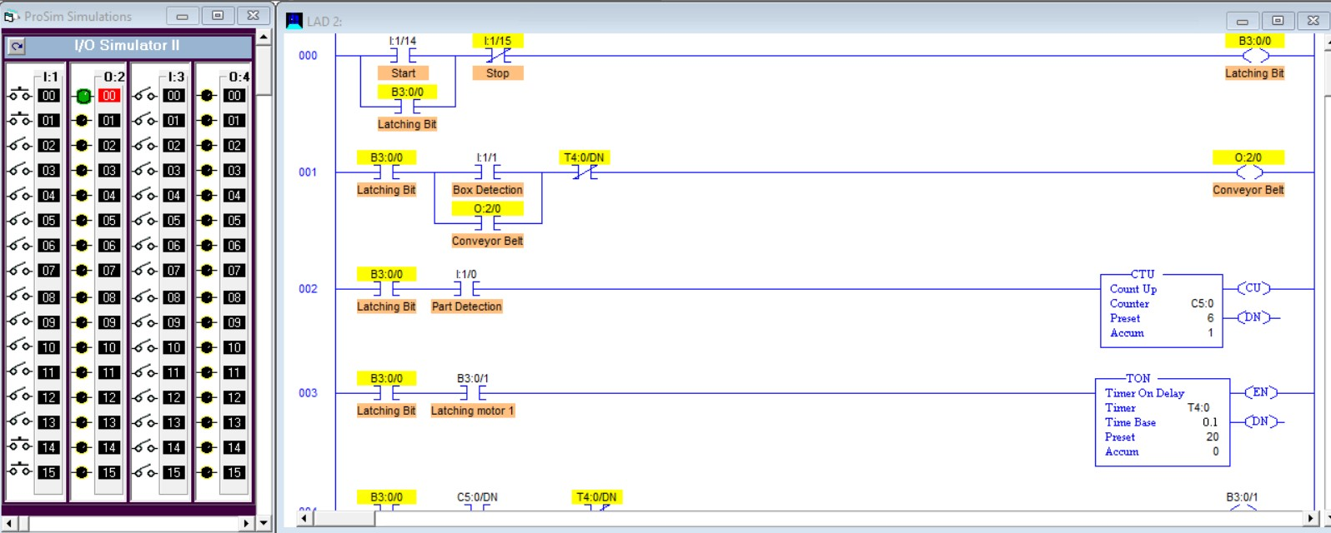

Lessons Learned
I considered using a Latch/Unlatch in place of the standard latching bit, however the program does work as is. Unfortunately, I completed the simulation and screenshots prior to the class presentation for this week so I did not realize we had some liberties in editing the program. I did go in after the presentation and try a couple of different ways to accomplish the same end goal.

Author's Biography
I am currently working towards finishing up my associate degree from DeVry. I have over 15 years of Industrial Manufacturing experience. I started out in operations, running the systems controlling my process equipment. I then moved into Instrumentation and Controls, dealing with installing, calibrating, and repairing sensors in the field. I began my education at DeVry to help me move into Industrial Automation. I have since become a Supervisor over Electrical, Instrumentation, and Automation at my facility. The facility I’m currently at is a Co-Generation Plant that produces steam and electricity. I am responsible for everything electrical, from 24VDC control power to our 34.5kV distribution network. My experience with PLCs includes Allen Bradley PLC 5, SLC 500, MicroLogix, CompactLogix, and ControlLogix.

Works Cited
[1] Solutions, P. (2020) A brief history of programmable logic controllers (plcs), Process Solutions, Inc. Available at: https://processsolutions.com/a-brief-history-of-programmable-logic-controllers-plcs/ (Accessed: 17 October 2023).

[2] Brown, H. (n.d.). The Father of PLC’s: How Richard Morley Revolutionized the Automation Industry. Blog.radwell.com. Retrieved October 17, 2023, from https://blog.radwell.com/the-father-of-plcs-how-richard-morley-revolutionized-the-automation-industry
‌
[3] History of Allen Bradley PLC. (2017, August 18). The Automization. https://theautomization.com/history-of-allenbradley/
‌

